Project Design Phase-II
Data Flow Diagram & User Stories

Date | 20 February 2026
Team ID | LTVIP2026TMIDS37708
Project Name | Online Payment Fraud Detection Using Machine Learning
Maximum Marks | 4 Marks

Data Flow Diagrams:
A Data Flow Diagram (DFD) is a traditional visual representation of the information flows within a system. A neat and clear DFD can depict the right amount of the system requirement graphically. It shows how data enters and leaves the system, what changes the information, and where data is stored.
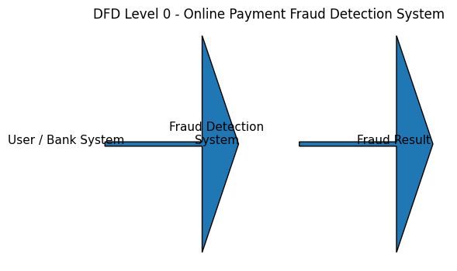

User Stories
Use the below template to list all the user stories for the product.
User Type | Functional Requirement (Epic) | User Story Number | User Story / Task | Acceptance Criteria | Priority | Release
Customer (Mobile user) | Transaction Monitoring | USN-1 | As a user, I can enter transaction details to check if it is fraudulent. | System predicts fraud status | High | Sprint-1
Customer (Web user) | Real-time Prediction | USN-2 | As a web user, I can upload transaction data for fraud detection. | Prediction result is displayed | High | Sprint-1
Bank Officer | Fraud Analysis Dashboard | USN-3 | As a bank officer, I can view flagged fraudulent transactions. | Dashboard shows fraud list | High | Sprint-2
Administrator | Model Management | USN-4 | As an admin, I can retrain the fraud detection model with new data. | Model updates successfully | Medium | Sprint-2

